**Funder Page Documentation:**

This Document Guides you to create a Funder, edit any Funder.

**Add Funder:**

Link to add Funder can be referred to screen shot attached:

CL- Loan --> GetCapital Configurations--> Add Funder (Link)

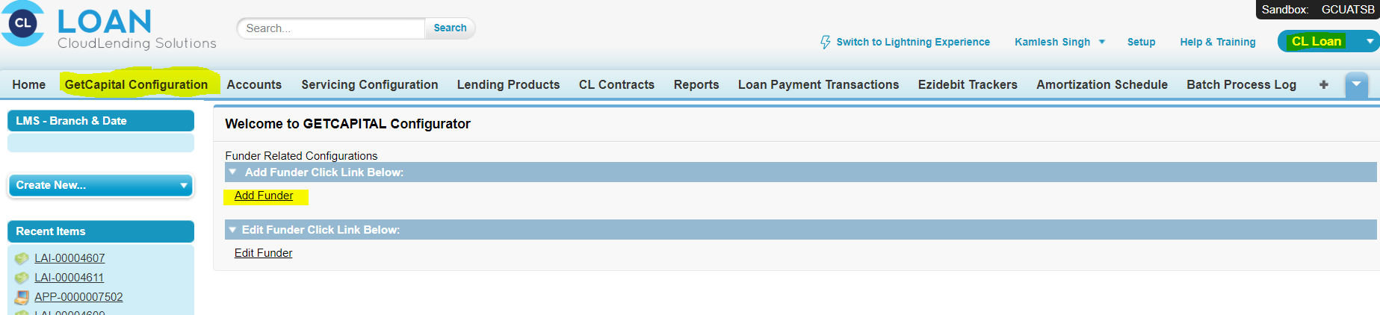

Click the Link it will redirect to add Funder Page:

As seen in the screen shot:

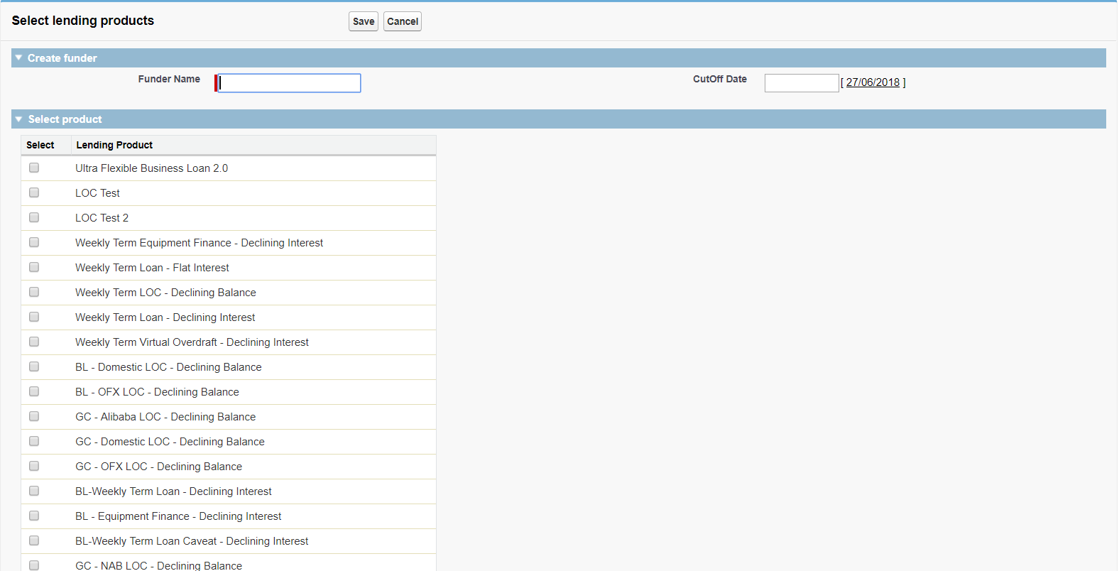

In Add Funder below are the validations added:

1) User won't be able to add any duplicate Funder see the screen shot the error message it populates:

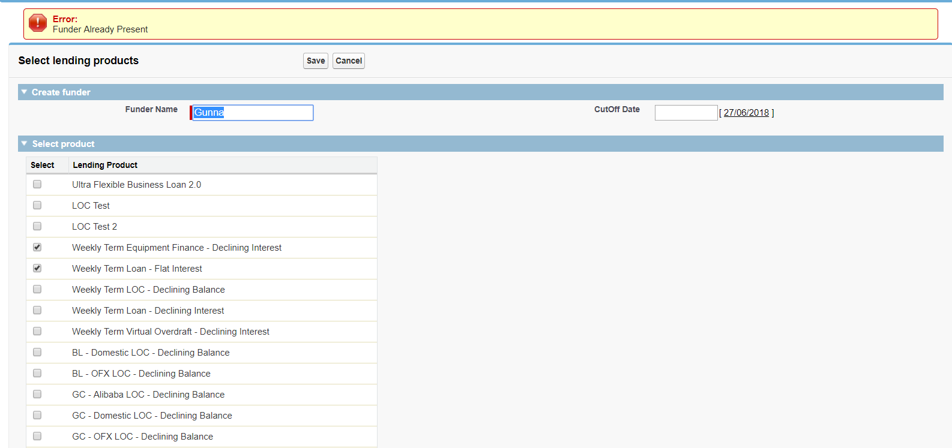

2) User won't be able to create the Funder without selecting the products

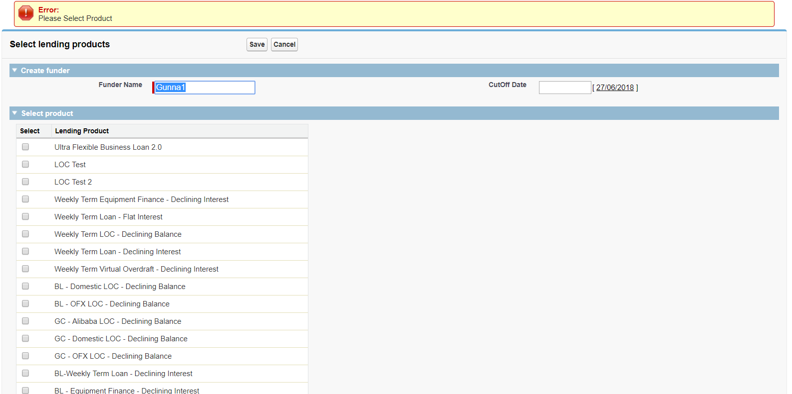

Now if accurate data is filled in the required fields it will create the funder and screen will be redirected to funder detail page:

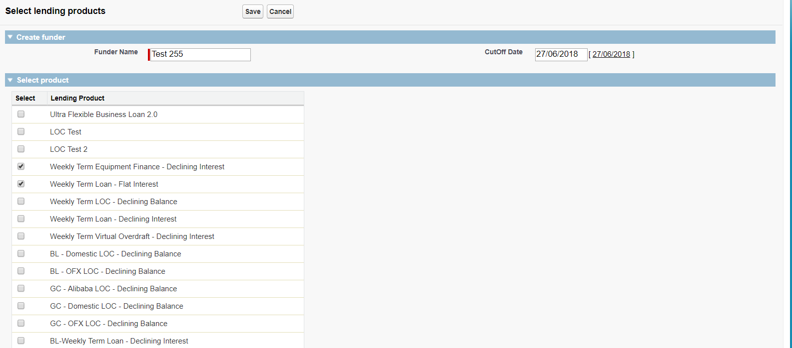

User can verify the Name of funder, Cutoff date and product assigned to that funder as seen below:

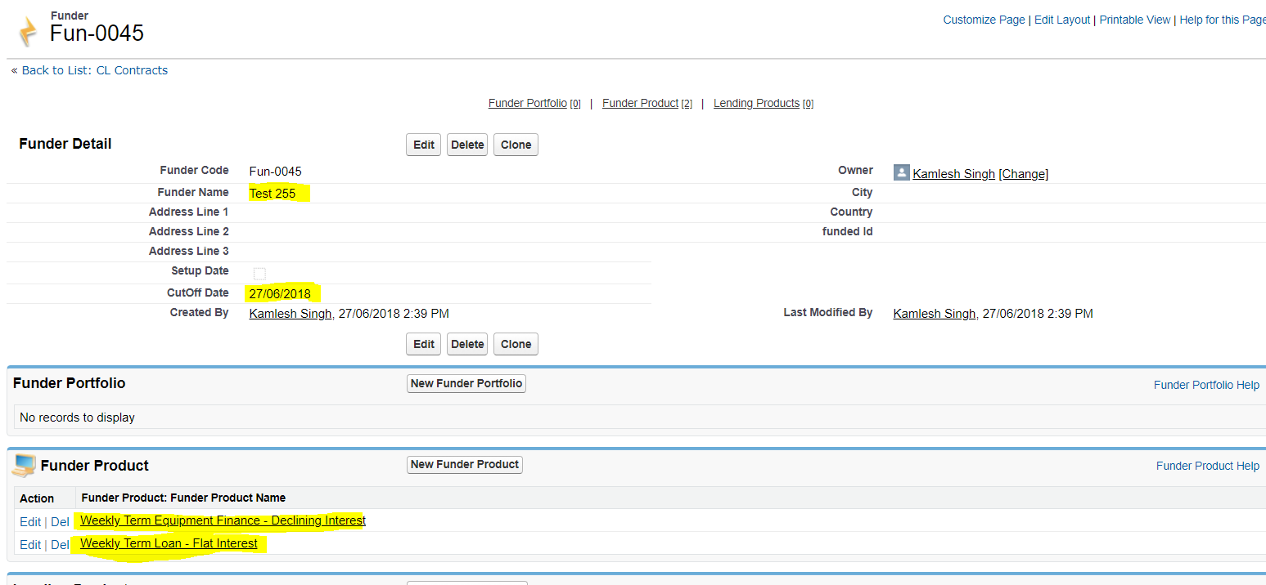

**EDIT FUNDER LINK:**

To Edit the Funder please refer the below Link:

CL- Loan --> GetCapital Configurations--> Edit Funder (Link)

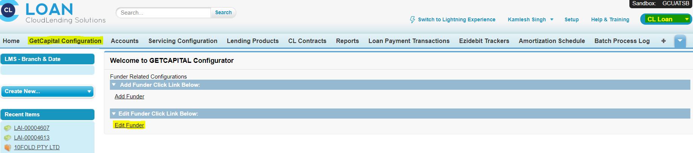

After Clicking the link the page will redirect to New Page as seen below :

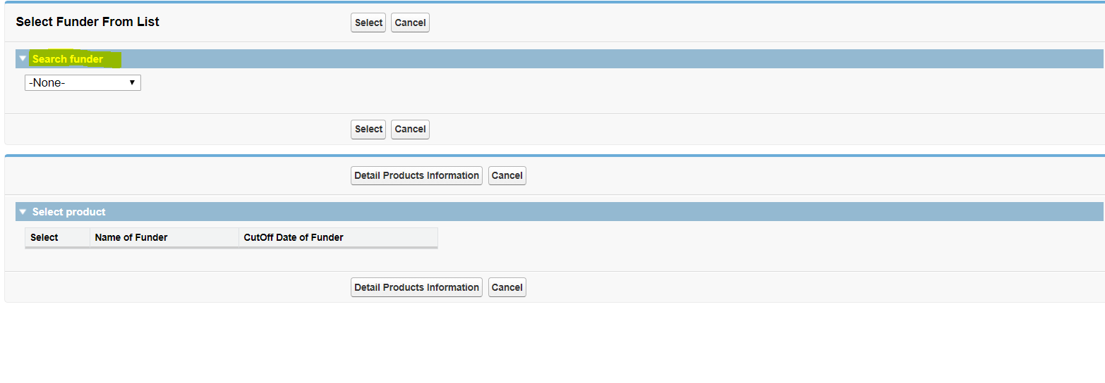

The User can select any Funder from the drop down named as Search Funder

Then User can get the details of that Funder and the next screen will be displayed as below:

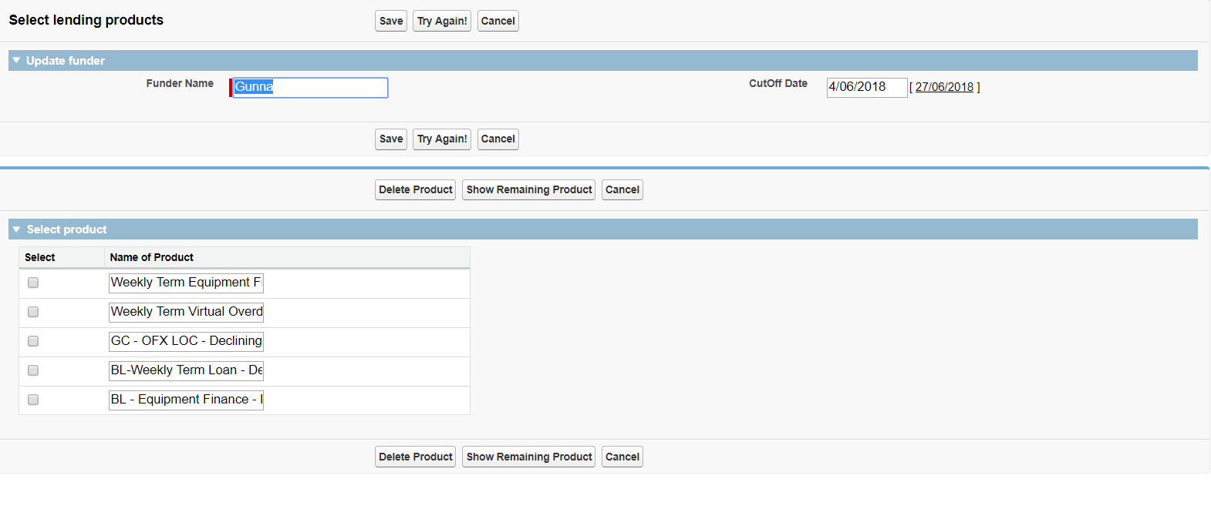

Validation in this page is as below:

1) User won't be able to update the funder name if new name is a duplicate name.

2) User can't delete the Product from Funder if already funder is allocated to any contract for that

Product

What User can Edit/Update:

1) Name of Funder

2) Cutoff date of funder

3) Delete Product from Funder (To delete the funder User can multiselect the product as seen in screen and click Delete Product button)

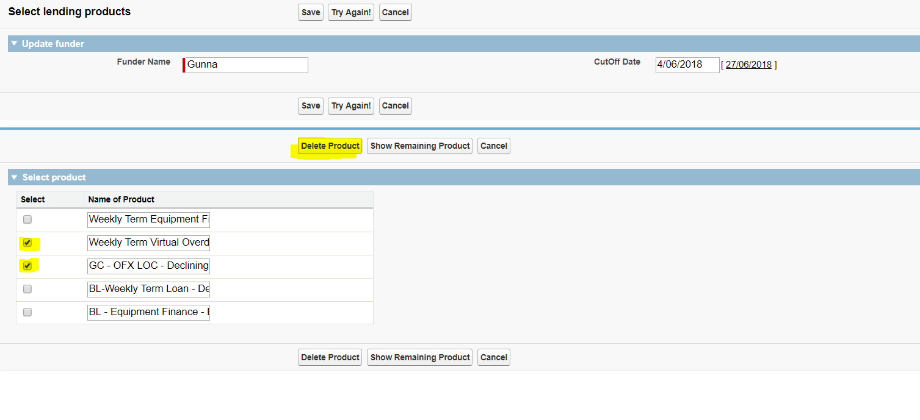

4) Add New Funder (To add New Product to this specific funder user can click Show Remaining Product then user can multiselect the products needs to be added and save)

